Linux Environment Variable Assignment

- Create a script named “myscript” in current directory to do the following.
- create a dir named “subd1” in current directory
- mkdir subd1

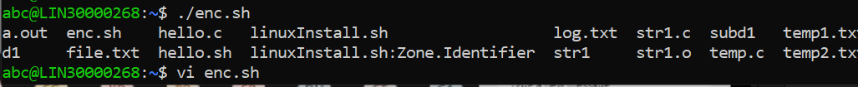

- create a file named “dircontent” with contents of the current directory
- ls -l > ./subd1/dircontent

- display the contents of the file “dircontent”
- cat ./subd1/dircontent

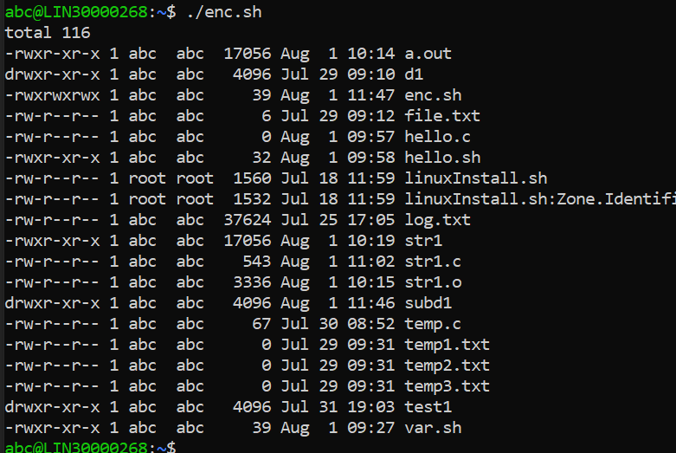

- display the contents of a non existing file named “unknownfile”
- cat unknown
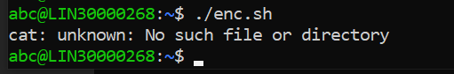

- Run the script and validate the output in following cases
- Redirect only the stdout to an o/p file named stdout.txt
- Redirect only the stderr to an o/p file named stderr.txt
- Redirect both stdout and stderr to an o/p file named stdall.txt
- Display all o/p and error and also redirect both stdout and stderr to an o/p file named stdall.txt

- Redirect the output of command below using pipe (|) to wc and get the output .
- ls -l

